Data Science-Univariate

- Mean,Median,Mode

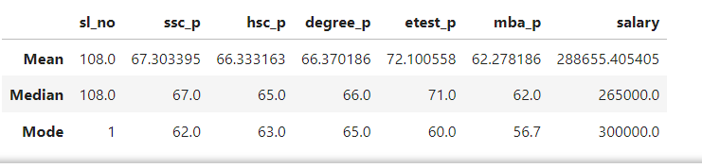

This table provides summary statistics for a placement dataset containing several variables related to students' academic and employment data. Here’s an explanation of each row:

Mean
The mean is the average value of each column in the placement data, representing the central tendency of the data.
- ssc_p: 67.30% is the average percentage obtained in secondary school.
- hsc_p: 66.33% is the average percentage in higher secondary school.
- degree_p: 66.37% is the average percentage obtained in the degree program.
- etest_p: 72.10% is the average score in the entrance test.
- mba_p: 62.28% is the average percentage obtained in the MBA program.
- salary: ₹288,655.41 is the average salary of the individuals in the dataset.

Median
The median is the middle value when the data is arranged in ascending order. It’s less affected by outliers compared to the mean.
- ssc_p: 67% is the middle value of secondary school percentages, meaning half the students scored below and half above this.
- hsc_p: 65% is the middle value of higher secondary school percentages.
- degree_p: 66% is the middle value of degree percentages.
- etest_p: 71% is the middle value of entrance test scores.
- mba_p: 62% is the middle value of MBA percentages.
- salary: ₹265,000 is the middle salary, showing that half the students earn less than this, and half earn more.

Mode
The mode is the most frequently occurring value in each column.
- ssc_p: 62% is the most common secondary school percentage.
- hsc_p: 63% is the most common higher secondary percentage.
- degree_p: 65% is the most common degree percentage.
- etest_p: 60% is the most frequent entrance test score.
- mba_p: 56.7% is the most frequent MBA percentage.
- salary: ₹300,000 is the most common salary.

Real-Time Insights From This Data:
Academic Performance Distribution:
- The average scores across ssc_p, hsc_p, degree_p, and mba_p are fairly close, suggesting consistency in academic performance.
- The entrance test scores (etest_p) have the highest mean (72.10%), indicating that students tend to perform better in entrance exams than in degree or MBA exams.
Salary Insights:
- The average salary (₹288,655.41) is higher than the median salary (₹265,000). This suggests that a few higher salaries may be pulling up the average.
- The most common salary (₹300,000) is higher than both the mean and the median, indicating that most people earn around ₹300,000 but outliers with lower salaries reduce the median.
Outliers and Distribution:
- The gap between the mean and median in salary suggests skewness in the data, possibly due to some outliers (either very high or low salaries).
- The relatively close values of mean and median in academic scores indicate that there is a normal distribution for these variables without extreme outliers.
Common Traits:
- Many students seem to score around 65% in their degree and MBA percentages, as reflected by the mode in degree_p and mba_p.
- Students often achieve around 62% in their secondary school scores and 63% in their higher secondary scores, showing a pattern of slightly lower scores in early education, with improvement in later stages.

